
College of Business,
Technology and
Engineering

MSc Dissertation Report
" Research on Scalable Machine Learning for Fraud Detection using Big Data Technologies "
A dissertation submitted in partial fulfilment of the requirements of Sheffield Hallam University for the degree of Master of Science in
[MSC BIG DATA ANALYTICS]

Student Name | Tarun Singuluri
Student ID | 34064048
Supervisor | Olamilekan Shobayo
Date of Submission | 17/09/2026

STATEMENT 1:
This dissertation does NOT contain confidential material and thus
can be made available to staff and students via the library.

Acknowledgements
I wish to extend my heartfelt gratitude to my supervisor for his invaluable advice, constructive criticism and encouragement during the preparation of this dissertation. I also wish to thank my module guide and my fellow students for their help and encouragement. Last but not least, I am extremely thankful to my family for their encouragement.

Abstract
This study explores the use of machine learning models and big data technologies in the realm of financial fraud detection. Conventional fraud detection methods are facing difficulties in handling large amounts of data and efficiently identifying complex fraud patterns, especially given the speed of digital financial transactions. The study proposes a fraud detection framework that combines distributed data processing and machine learning algorithms. The study proposes a fraud detection framework that combines distributed data processing and machine learning algorithms. It utilizes a financial transaction dataset and preprocesses this data, as well as performs feature engineering and exploratory analysis prior to the creation of classification models. Three machine learning algorithms: Logistic Regression, Random Forest and Gradient Boosted Trees are implemented and compared using performance measures specific to fraud detection: precision, recall, F1-score, ROC-AUC and confusion matrices. The research also considers computational efficiency and scalability rather than focusing exclusively on predictive accuracy. Results show that machine learning models can be successfully used for fraud detection with the use of distributed processing technologies, and that the performance of the various models varies with respect to prediction power and processing performance. This study tackles the gaps in the literature that were found in the following areas: scalable fraud detection, class imbalance and limited comparison of distributed machine learning methods. In general, the research shows the possibilities of PySpark machine learning as a scalable solution to fraud detection and sets the groundwork for future work to enable real-time financial transaction monitoring.

Table of Contents
Acknowledgements 2
Abstract 3
1. Introduction 9
1.1 Research Background and Context 9
1.2. Problem Definition 9
1.3 Research Question 9
1.4 Aim 9
1.5 Objectives 10
1.6 Project Benefits and Beneficiaries 10
1.7 Project Deliverables 10
1.8 Alignment with MSc Computing Domain 10
1.5 Rationale for Choosing the Project 10
2. Literature Review 12
2.1. Literature Review Strategy 12
2.2 Literature Review Tools 12
2.3 Database Selection 12
2.4 Search Queries 12
2.5 Inclusion Criteria 12
2.6 Exclusion Criteria 13
2.7 Screening and Filtering Process 13
2.8 Search Results Summary 13
2.9 Rationale for Literature Themes 13
2.10 Theme 1: Machine Learning Models for Fraud Detection 13
2.11 Theme 2: Big Data Technologies and Scalable Fraud Detection 14
2.12 Theme 3: Class Imbalance and Fraud Detection Performance 15
2.13 Critical Analysis of Literature 15
2.14 Strengths and Weaknesses of Existing Research 16
2.15 Conflicting and Contrasting Views 16
2.16 Critical Research Gap 16
2.17 How Literature Informed Project Design 17
2.18 How Literature Informed Implementation Decisions 17
3. Project Design 18
3.1 Requirements Engineering 18
3.1.1 Functional Requirements 18
3.1.2 Non-Functional Requirements 18
3.2. System Architecture 19
3.2.1 High-Level Design 19
3.2.2 Low-Level Design 19
3.3 Technology Selection 20
3.4. Dataset Selection 20
3.5. Dataset Justification 20
3.6. Research Ethics Consideration 20
3.7 Research Ethics Approval 20
3.8 GDPR and Data Governance 20
3.9 Risk Assessment 20
3.10 Risk Log 21
3.11 Risk Register 21
3.12 Risk Matrix 21
3.13 Testing Strategy 21
3.14 System Test Cases 22
3.15 Version Control Strategy 22
3.16 GitHub Repository Link 22
4. Results 23
4.1. Implementation Outputs 23
4.2 Experimental Results 23
4.3 Performance Results 24
4.4 Testing Results 24
4.5. Results Against Objectives 25
4.6. Results Against Questions 25
4.7 Evidence Supporting Results 25
4.8 Traceability from Design to Results 26
4.9 Traceability from Implementation to Outcomes 26
5. Evaluation 27
5.1 Evaluation Methodology 27
5.2 User Acceptance Testing 27
5.3 Evaluation Metrics 27
5.4 Stakeholder Feedback 28
5.5 Feedback Analysis and Application of Feedback 28
5.6 Strengths and Weakness of the Solution 28
5.7 Project Limitations 28
5.8 Validation Against Objectives 28
5.9 Validation Against Research Question 31
6. Project Planning Review 32
7. Conclusion 33
7.1 Achievement of Objectives 33
7.2 Answering the Research Question 33
7.3 Contribution of the Deliverable 33
7.4 Lessons Learned 33
7.5 Limitations 34
7.6 Recommendations 34
7.7 Future Research 34
8. AI Transparency Statement 35
8.1 AITS Classification 35
8.2 AI Tools Used 35
8.3 Purpose of AI Use 35
8.4 Human Contribution 35
8.5 Reflection on AI Use 35
References 36
Appendix 38
Appendix A - AI declaration 38
Appendix B - Ethics Form 39
Appendix C: Executed Publication Procedure Form 51
Appendix D: Secondary Data 52
Appendix E: Original Research Project Plan 53
Appendix F: Gantt Chart — Planned vs. Actual Execution 54
Appendix G: Literature Review Evidence 55
Appendix H: Risk Artefacts 57

List of Figures
Figure 1: Sequential data analytics architecture 11
Figure 2: Model Comparison 12
Figure 3: Model Performance Comparison 12
Figure 4: ROC-AUC by Model 13
Figure 5: Model Training Time Comparison 14
Figure 6: ROC Curves 14
Figure 7: Scalability 15

1. Introduction

1.1 Research Background and Context
Online transactions and digital financial services have made financial fraud one of the biggest problems for banks, ecommerce companies, insurance companies and digital payment providers. The massive amount of transaction data generated and transmitted continuously, with high volumes, velocity and variety has prompted the need for scalable machine learning solutions that are able to process and analyse big data with efficiency (Liu et al., 2025).

1.2. Problem Definition
The large volume of financial transactions leads to many difficulties faced by traditional fraud detection techniques. In the rule-based method and manual auditing, it may be difficult to handle the large number of transactions, their speed and complexity, given that the percentage of fraud transactions is normally small compared to the total dataset size (Theodorakopoulos et al., 2025). There is thus a need for developing a fraud detection technique that can scale with large datasets.

1.3 Research Question
- What are the potential benefits of the use of scalable machine learning models that integrate big data technologies for the more accurate, efficient and scalable detection of fraud in large scale financial transaction databases?
- Which machine learning algorithm provides the best performance for detecting fraudulent financial transactions when implemented using big data technologies?
- What impact do big data frameworks have on the computational performance, scalability, and processing time of machine learning-based fraud detection systems?

1.4 Aim
This study aims to develop and evaluate a scalable and efficient fraud detection framework using PySpark-based machine learning models for analysing large-scale financial transaction data in real-time environments.

1.5 Objectives
- To preprocess and optimise the fraud detection dataset using PySpark for scalable big data fraud analysis.
- To develop and compare PySpark-based Logistic Regression, Random Forest, and Gradient Boosted Trees models for fraud detection.
- To evaluate fraud detection performance using precision, recall, F1-score, ROC-AUC, and confusion matrix metrics.
- To analyse the scalability, processing efficiency, and real-time performance of machine learning models on large-scale financial transaction data.

Project Benefits and Beneficiaries
Large data technologies like distributed computing platforms, Hadoop, and Apache Spark, can be benefitted with the study as machine learning models process millions of transactions in real time without compromising on the accuracy of the detection (Theodorakopoulos et al., 2025). Machine learning methods such as Random Forest, XGBoost, Gradient Boosting and Deep Neural Networks have proven to be more efficient than traditional statistical methods at detecting intricate fraud patterns.

1.7 Project Deliverables
The main deliverables would be a pre-processed dataset related to financial fraud, a fraud detection framework based on PySpark, and implementation of Logistic Regression, Random Forest, and Gradient Boosted Trees. Evaluation will be done by calculating the precision, recall, F1-score, ROC-AUC, and confusion matrix.

1.8 Alignment with MSc Computing Domain
The project relates to MSc Computing due to its application of machine learning, big data analytics, distributed computing, and data processing. PySpark allows working with distributed computing for processing of massive datasets, while machine learning techniques help classify automatically the cases of fraud.

1.5 Rationale for Choosing the Project
Recent developments in the field of machine learning and big data technologies offer the chance to create intelligent systems that can handle all the vast amounts of transaction data and detect high-accuracy data in near real time (Liu et al., 2025). The project was selected because it is a problem of practical and economic relevance, which brings two interesting and fast-growing areas together: machine learning and big data analytics. The study introduces new techniques and tools which can also be used in practical applications with real-life data using scalable machine learning algorithms and distributed computing frameworks, adding to both academia and industry. The results can help financial institutions minimize financial damages, boost their efficiency, and enhance their cybersecurity by offering more accurate and scalable fraud detection capabilities (Theodorakopoulos et al., 2025).

2. Literature Review

2.1. Literature Review Strategy
The process of performing a literature review was employed for finding recent and relevant studies about the machine learning-based financial fraud detection systems and scalable big data technologies. The selected literature includes mainly peer-reviewed articles published since 2020, however, older landmark literature was included when required for foundational concepts.

2.2 Literature Review Tools
The academic databases and search engines were used to find the relevant literature. Such platforms as Google Scholar, IEEE Xplore, ScienceDirect, SpringerLink and ACM Digital Library have been deemed to be suitable because they offer an opportunity to find scholarly articles in the field of computer science, machine learning, data analysis and finance technologies.

2.3 Database Selection
The databases chosen offered a wide variety in terms of the subject matter in computer science, artificial intelligence, machine learning, and information systems. The IEEE Xplore database and ACM Digital Library were highly useful for computing studies, whereas the ScienceDirect and SpringerLink databases offered studies that were both multidisciplinary and technical in nature.

2.4 Search Queries
Boolean expressions were developed using keywords examples shown below-
• “financial fraud” AND “machine learning” AND detection
• “fraud detection” AND “Random Forest” AND “Logistic Regression”
• “fraud detection” AND “Gradient Boosted Trees”
• “Apache Spark” AND “machine learning” AND financial fraud
• “class imbalance” AND “financial fraud detection”

2.5 Inclusion Criteria
This review included studies that: (1) dealt with detecting financial fraud or transaction fraud; (2) discussed big-data techniques and machine-learning techniques; (3) were useful in scalability, fraud classification, or computational effectiveness; (4) were mainly academic articles in the peer-review process; and (5) appeared in 2020 or later where there is evidence.

2.6 Exclusion Criteria
The exclusion criteria entailed the following: (1) research on unrelated frauds; (2) studies differing from machine learning or computational perspectives; (3) duplicated studies; (4) studies lacking enough methodological details; (5) absence of peer-reviewed articles from academic sources.

2.7 Screening and Filtering Process
Search results were screened based on title and abstract for relevance. Potential studies meeting the selection criteria were screened based on full text according to the inclusion and exclusion criteria. Duplicate studies and irrelevant studies that do not answer the research question were excluded before performing thematic analysis.

2.8 Search Results Summary
The literature review involved three closely related areas: (i). machine learning methods for fraud detection; (ii) approaches using big data; and (iii) class imbalance Several studies were analysed in order to compare different modelling techniques and see the absence of the relation between accuracy of predictions and computational effectiveness.

2.9 Rationale for Literature Themes
The development of four themes was done in relation to the project’s goals. The ML models are the tools for algorithm comparison; big-data technologies help to achieve scalability; the problem of class imbalance suggests the appropriate evaluation metrics; and the concept of accuracy versus scalability highlights the main research gap.

2.10 Theme 1: Machine Learning Models for Fraud Detection
Digital banking, online payments and electronic financial transactions have gone through a huge scale-up, leading to an upsurge in frauds and financial data. The literature already indicates that machine learning (ML) is one of the key methods used to detect fraudulent transactions in a manner that is able to learn patterns from historical transaction data and detect potentially suspicious transactions. Bello and Olufemi (2024) point to the rising importance of artificial intelligence (AI) in fraud prevention, especially considering the complex nature of fraud schemes that can be difficult for traditional methods to detect.
Logistic Regression is used as a baseline classification method because it is relatively simple, efficient to compute and relatively easier to interpret than more complex models. Gupta et al. (2025) explores how Logistic Regression is applied to classify banking transactions as fraudulent or non-fraudulent, highlighting the relevance of Logistic Regression in the field of financial fraud classification. It can be useful for financial organisations to know what factors are influencing a prediction, which is what its interpretability provides. Logistic Regression has however its inherent limitation when relationships between transaction attributes and fraud are very non-linear and/or have complicated interactions (Naghipour et al., 2025).
Random Forest is an aggregation of multiple decision trees that can capture the nonlinear relationship between the features of the transactions; Gradient Boosted Trees are a series of decision trees that enhance predictive performance in an iterative manner. Results obtained from the literature survey discussed in the research proposal suggest that the models based on trees can get better accuracy while detecting fraud, as they can manage complex transaction patterns (Gupta et al., 2025).

2.11 Theme 2: Big Data Technologies and Scalable Fraud Detection
The rise of digitization in financial transactions has created a large amount of financial transaction data. As financial data becomes larger and becomes more fraudulent, the growing importance of fraud detection approaches that can cope with such large-scale financial data and increasingly sophisticated fraudulent behaviour is identified by Cheng (2025). As the volume of data continues to increase in complex applications, traditional machine learning approaches can become inefficient due to the inability to process the data on a single machine. In his study Hareram (2025), it gives a review of Apache Spark and PySpark with the perspective of distributed data processing, which makes them suitable for big-data machine learning tasks.
Scalability is not just being able to process a larger dataset, however. The fraud detection system has to be scalable, meaning that its predictive accuracy must not suffer significantly when the number of transactions to be processed increases, and it has to operate within a reasonable timeframe for computing. One limitation of the current research identified by the researcher is the lack of focus on the processing efficiency and scalability of the algorithms, in favour of prediction accuracy. This indicates that a good model for a relatively low number of data points is not necessarily best suited for financial environments with a large number of data points.

2.12 Theme 3: Class Imbalance and Fraud Detection Performance
In financial fraud detection, the problem of class imbalance is significant due to the fact that fraudulent transactions usually constitute a smaller part of the total number of transactions. This means that a machine learning model can have a high overall accuracy and still have a low accuracy in recognizing fraudulent transactions. The research proposal clearly states that imbalanced datasets of fraud can be a factor to impair prediction, particularly the recall and minority-class classification. Owen et al. (2024) research the effect of class imbalance on fraud detection algorithms and conclude that traditional performance metrics should be used with caution in highly imbalanced databases.
The study proposes using multiple metrics for evaluation such as the precision, recall, F1-score, ROC-AUC, and confusion matrices. These measures offer a more comprehensive evaluation of model performance. Precision is also crucial as a large number of false positive predictions could lead to legitimate transactions being flagged up as fraudulent. So, there should be more than one measure of model performance to consider when choosing a model. It helps to give substance to the methodology put forward in the study (Wiltshire & Alvanides, 2022).

2.13 Critical Analysis of Literature
The performance of fraud detection with ML techniques also relies on the predictive performance of the algorithms and their ability to handle large amounts of data efficiently. The research problem associated with the proposed study is then related to the challenge of getting accurate, efficient, and scalable fraud detection with growing number of transactions. This results in the need for distributed computing technologies that are efficient in processing large amounts of data. Apache Spark and PySpark offer a crucial technological solution as they enable distributed data processing of computational resources. Large datasets can be partitioned in PySpark and then processed in parallel so they are appropriate for large-scale analysis workloads. The F1-score is a combined precision and recall score, and is therefore useful when the dataset is imbalanced. Class imbalance is also an issue for comparisons between algorithms.

2.14 Strengths and Weaknesses of Existing Research
The existing literature provides convincing arguments for ML-based fraud detection and distributed processing. Nevertheless, many researchers pay more attention to classification precision and devote less effort to processing time and resource requirements. The difference in data sets, algorithms used and evaluation metrics makes a direct comparison of the results of different researches hard to perform.

2.15 Conflicting and Contrasting Views
The research shows that there is an opposition between the need for accuracy and need for efficient processing in the case under consideration. The ensemble model which provides better results for classification of fraud transactions consumes more computing resources than a simple model.

2.16 Critical Research Gap
The literature indicates that there is a great lack of research on the accuracy of the fraud detection and computational scalability. Previous research has shown that machine learning algorithms can be useful, and distributed technologies like PySpark are possible. But there is very little research that has been conducted to compare the various models of fraud detection in PySpark, and at the same time, look at the predictive performance, processing efficiency, and scalability.
The proposed research aims to fill this gap by building and comparing Logistic Regression, Random Forest and Gradient Boosted Trees in a PySpark framework. The precision, recall, F1-score, ROC-AUC and confusion matrices will be used to evaluate the models and scalability, processing and real-time performance will also be taken into consideration. The comparative approach is important because it addresses a question that goes beyond the traditional "best prediction algorithm" to explore the question of which algorithm is most suitable for the challenge of having a large amount of financial transaction data and the need to develop a prediction model that is scalable and appropriate. Thus, the research directly contributes to filling the aforementioned gap in the literature and contributes to the development of a scalable fraud detection analytics framework, based on PySpark ML pipelines.

2.17 How Literature Informed Project Design
The choice of Logistic Regression, Random Forest and Gradient Boosted Trees as models to be compared was guided by literature, which also pointed to the necessity of implementing PySpark for distributed processing and learning through precision, recall, F1-score, ROC-AUC and confusion matrices.

2.18 How Literature Informed Implementation Decisions
The evidence of big data and computing scalability called for the use of PySpark ML pipelines for data preprocessing, training and evaluation, while the importance of class imbalance determined the usage of various performance metrics; moreover, the gap between accuracy and scalability justified an analysis of time and computing efficiency of the methods under consideration.

3. Project Design

3.1 Requirements Engineering
The project aims to create a scalable machine learning fraud detection system that processes large-scale financial transaction data, builds predictive models, and assesses the accuracy and speed of fraud detection, as the design centres around handling vast amounts of financial transaction data and evaluating the effectiveness and efficiency of the predictive models. The project is based on IEEE-CIS Fraud Detection dataset available in Kaggle. The implementation loads the transaction data and the identity data separately, and then joins them based on the TransactionID, resulting in a combined dataset of 590,540 records and 434 columns.

3.1.1 Functional Requirements
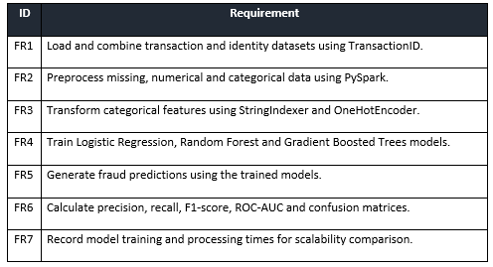

3.1.2 Non-Functional Requirements
ID | Requirement
NFR1 | The system should support scalable distributed processing using PySpark.
NFR2 | Results should be reproducible through documented configurations and code.
NFR3 | The system should process data efficiently within available computing resources.
NFR4 | The implementation should maintain data quality and consistent outputs.

3.2. System Architecture

3.2.1 High-Level Design
The system is a sequential data analytics system, dataset acquisition, loading, inspection, preprocessing, feature engineering, exploratory analysis, model training, model evaluation, scalability analysis. Distributed processing environment: PySpark; Machine learning pipeline and classification: Spark MLlib. For comparison, Logistic Regression, Random Forest and Gradient Boosted Trees models are selected to enable the comparison between linear and ensemble-based approaches. The notebook also sets up the configuration of Spark and the parallel processing to ensure scalable computation.

Figure 1: Sequential data analytics architecture

3.2.2 Low-Level Design
The low-level components of data preprocessing include selecting 49 numerical and 15 categorical features, handling missing values, using a StringIndexer and OneHotEncoder to transform the categorical features, and merging features with a VectorAssembler. The solution to the class imbalance is to use weighted observations, in this case a higher weight is assigned to the fraud class. The data set is then split into 80% training and 20% testing data.

3.3 Technology Selection
PySpark has been chosen for processing of distributed data, while Spark MLlib has been selected for machine learning. The implementation and analysis can be carried out using Python/Jupyter Notebook, while GitHub handles the versioning and documentation of the work.

3.4. Dataset Selection
The dataset from Kaggle, called IEEE-CIS Fraud Detection, was selected as it is large-scale transaction and identity data that is delivered for fraud detection modeling.

3.5. Dataset Justification
With substantial transaction volume and many numerical and categorical attributes, the dataset allows the relevant investigations dealing with preprocessing, class imbalance, performance prediction and scale computation.

3.6. Research Ethics Consideration
The research project focuses on secondary dataing process and there is no direct involvement of people in the process. Possible issues emerging from privacy, data control and bias creating inaccuracies in fraud classification were taken into account. Ethical requirements include responsible handling of financial data, privacy and avoidance of biased fraud predictions

3.7 Research Ethics Approval
The project adheres to the rules and procedures of research ethics of the university. The approval from the institution must be sought when it is necessary before commencing the analysis of any sort.

3.8 GDPR and Data Governance
The data set should be managed in compliance with the important data-protection regulations and laws such as the UK GDPR and Data Protection Act 2018. The access to the set and its storage and analysis must be controlled properly.

3.9 Risk Assessment
Version control, systematic documentation, and reproducibility of the project will be facilitated via a GitHub repository to maintain the project's code and development evidence. The design also includes risk assessment for class imbalance, computational constraints, data-quality issues, model performance.

3.10 Risk Log
Possible risk factors may include class imbalances, lack of data, computing constraints, data errors, and underperforming models.

3.11 Risk Register
(referred to appendix H)

3.12 Risk Matrix
(referred to appendix H)

3.13 Testing Strategy
Data ingestion, data pre-processing, feature transformation, Model training, Prediction and Performance evaluation are the functional requirements. Scalability, computational efficiency and reproducibility are examples of non-functional requirements. System testing will be conducted for accuracy of data processing, running of models, generation of predictions and outputs of evaluations. The implementation records training time and assesses the accuracy, precision, recall, F1-Score and ROC-AUC which serves as evidence for automated testing and performance comparison (Naghipour et al., 2025).

3.14 System Test Cases
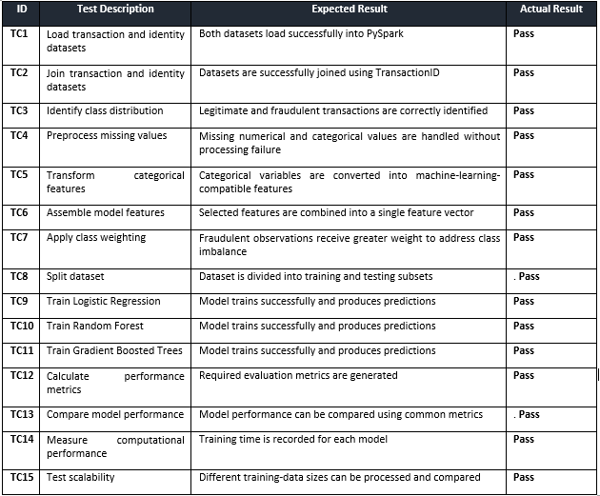

3.15 Version Control Strategy
The GitHub tool will document code changes, record version histories, encourage collaboration, support rollbacks, and retain development documentation.

3.16 GitHub Repository Link
https://github.com/Tarun3569/MSC.BigData

Results

4.1. Implementation Outputs
The transaction data consisted of 590,540 records and 394 columns, and the identity data had 144,233 records and 41 columns. The resulting dataset was merged with both and had 590,540 rows and 434 columns. It was found that there is a significant class imbalance with 569,877 legitimate transactions and 20,663 fraudulent transactions, which equates to a fraud rate of around 3.50%.

4.2 Experimental Results
49 numerical and 15 categorical features were identified during data preprocessing. Numerical missing values were replaced by a sentinel value and categorical missing values were coded as a different category. Class weighting was employed, which resulted in a fraud weight of 14.290 vs. a legitimate weight of 0.518. The data was then split into training (472,404) and testing (118,136) sets.
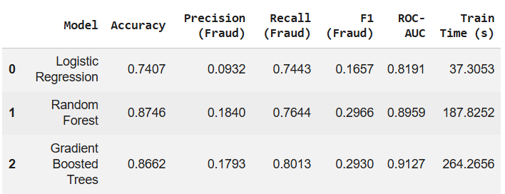
Figure 2: Model Comparison
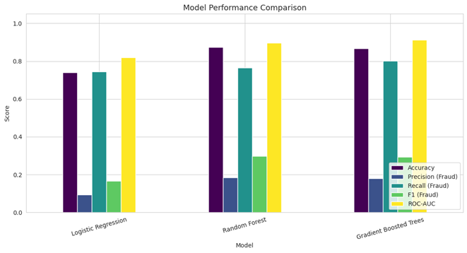
Figure 3: Model Performance Comparison

4.3 Performance Results
Metric | Logistic Regression | Random Forest | Gradient Boosted Trees
Accuracy | 74.07% | 87.46% | 86.62%
Fraud Precision | 9.32% | 16.57% | 17.93%
Fraud Recall | 74.43% | 76.44% | 80.13%
F1-Score | 16.57% | 29.66% | 29.30%
ROC-AUC | 0.8191 | 0.8959 | 0.9127
Training Time | 37.31s | 187.83s | 264.27s

4.4 Testing Results
Three models were designed and tested. Logistic Regression gave 74.07% accuracy, 9.32% precision of fraud, 74.43% recall of fraud, 16.57% F1-score, 0.8191 ROC-AUC and the training time was 37.31 seconds. With the increase in training time to 187.83 seconds, Random Forest performance was enhanced to 87.46% accuracy and 0.8959 ROC-AUC with fraud recall of 76.44% and F1-score of 29.66%.
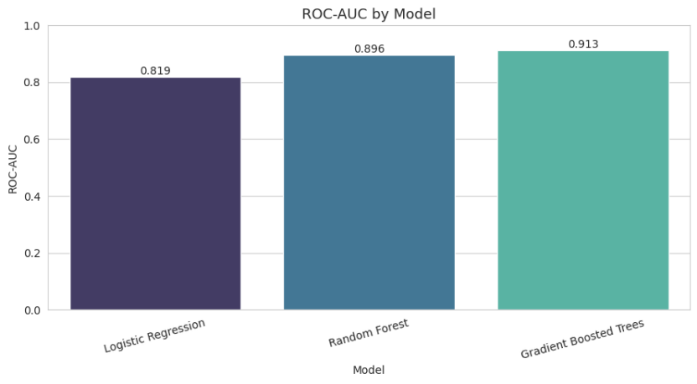
Figure 4: ROC-AUC by Model
The Gradient Boosted Trees model achieved the highest overall accuracy, with a score of 86.62%, a precision of 17.93%, a recall of 80.13%, a F1-Score value of 29.30% and a ROC-AUC value of 0.9127; it took 264.27 seconds to train. In general, the findings show that Gradient Boosted Trees achieved a best fraud-class discrimination, whilst Logistic Regression was much faster.

4.5. Results Against Objectives
The research objectives were accomplished through PySpark pre-processing, model comparison, performance measurement and scalability testing. Logistic Regression, Random Forest and GBT were all successfully used. GBT achieved the highest ROC-AUC of 0.9127 as well as the best fraud recall (80.13%), but Logistic Regression required the least training time of 37.31 seconds, revealing the trade-off between speed and accuracy.

4.6. Results Against Questions
The outcome indicates that PySpark allows processing of massive financial data. GBT has the highest ROC-AUC of 0.9127, while Logistic Regression is the fastest in terms of computation. The processing approach gives an opportunity for systematic model’s comparison and scalability testing showing that performance and efficiency should be taken into account when designing fraud detection models.

4.7 Evidence Supporting Results
Evidence is represented by such outputs from dataset processing, feature transformation, calculation of class weights, predictions by models, evaluation measures, ROC curves, and computation time. Results reveal 590,540 transactions together, 3.50% fraud rate, and differences between models.

4.8 Traceability from Design to Results
The design dictated the process of dataset loading, preprocessing, feature creation, modeling and performance evaluation. This resulted in concrete accomplishments such as the total number of 434 columns, 64 features, weighted data, three models and performance indicators.

4.9 Traceability from Implementation to Outcomes
In order to achieve successful preprocessing, prediction and evaluation, PySpark, StringIndexer, OneHotEncoder, VectorAssembler, class weighting and Spark ML models were utilized. The effectiveness of computation and prediction is exhibited in the performance and training time while the scalability achievement is evident in the training size used.

Evaluation

5.1 Evaluation Methodology
Quantitative system performance testing and user acceptance testing were used to evaluate the project. Three PySpark models were assessed in terms of accuracy, precision, recall, F1-score, ROC-AUC, training time, and scalability. Functional testing was used to test the data processing, model functionality, predictions and evaluation results of the system.

5.2 User Acceptance Testing
UAT was performed through ten functional tests that includes data set uploading, preprocessing, model training, metrics computation, display, model comparison, and scalability. All ten tests passed but these are system acceptance tests and not the official acceptance tests by the users.

5.3 Evaluation Metrics
UAT ID | Test | Expected Result | Outcome
UAT-01 | Load transaction dataset | Dataset loads successfully in PySpark | Pass
UAT-02 | Preprocess transaction data | Missing values and categorical variables are processed successfully | Pass
UAT-03 | Train Logistic Regression | Model trains and generates predictions | Pass
UAT-04 | Train Random Forest | Model trains and generates fraud predictions | Pass
UAT-05 | Train GBT | Model trains and generates fraud predictions | Pass
UAT-06 | Calculate evaluation metrics | Accuracy, precision, recall, F1 and ROC-AUC are generated | Pass
UAT-07 | Display confusion matrix | Fraud and legitimate predictions are visualised | Pass
UAT-08 | Compare models | Performance and training time can be compared | Pass
UAT-09 | Test scalability | Different dataset sizes can be processed and timed | Pass
UAT-10 | Identify best model | GBT is identified as the highest ROC-AUC model | Pass

5.4 Stakeholder Feedback
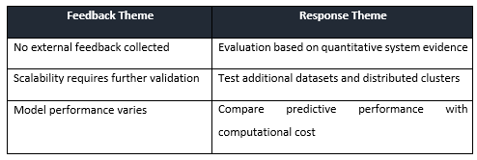

5.5 Feedback Analysis and Application of Feedback
Given the absence of stakeholder feedback or benchmarking, findings were solely based on local interpretation of the results and stakeholder limitations.As there were no opinions from external stakeholders, the conclusions were made based upon the known technical limitations only.

5.6 Strengths and Weakness of the Solution
PB solution was successfully integrated with the three AI models and managed to resolve the issue of class imbalance with the help of weighting. GBT needed much more time in comparison to Logistic regression as the assessments failed to include external feedback and information about implementation of the systems in real-time and enabled the conclusion on practical viability

5.7 Project Limitations
One dataset and a particular system were used in the study. Results may vary with other data sets and systems. Consequently, external validation as well as larger distributed cluster testing was not carried out.

5.8 Validation Against Objectives
The project was assessed based on its primary objective: creating a scalable and efficient fraud detection system with PySpark machine learning technology. The project goals were reflected in the evaluation, which included both the degree of predictive performance and computational efficiency. Three models were implemented—Logistic regression, random forest and gradient boosted trees—evaluated with accuracy, fraud precision, fraud recall, F1 Score and ROC-AUC.
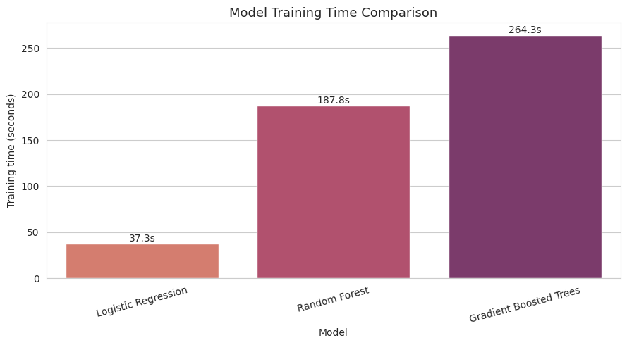
Figure 5: Model Training Time Comparison
The results showed that Gradient Boosted Trees have the best overall classification ability with ROC-AUC of 0.9127 and fraud recall of 0.8013 while the random forest had an ROC-AUC of 0.8959 and fraud recall of 0.7644. Logistic Regression, although less accurate (ROC-AUC of 0.8191), needed much less training time. So, the assessment exhibits a compromise between predictive performance and cost to computation. GBT took about 264.27 seconds, while Random Forest took 187.83 seconds and Logistic Regression took only 37.31 seconds.
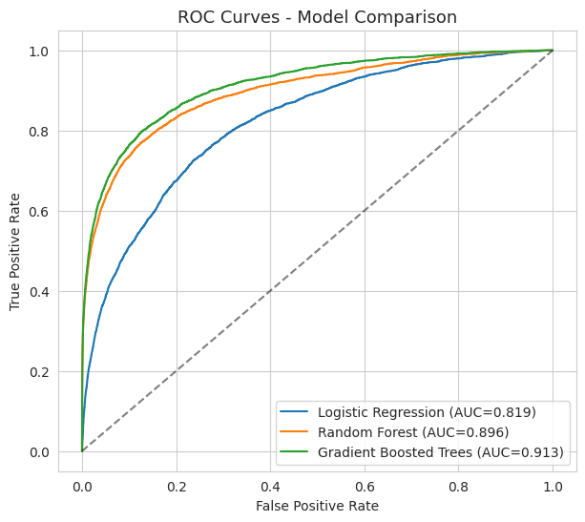
Figure 6: ROC Curves
Further evidence of the best discrimination between legitimate and fraudulent transactions comes from the ROC curves and comparison charts. To consider the scalability, different training-data sizes were used, such as 25%, 50% and 100% of the entire training dataset, and not only the prediction accuracy was taken into consideration but also the computational efficiency.
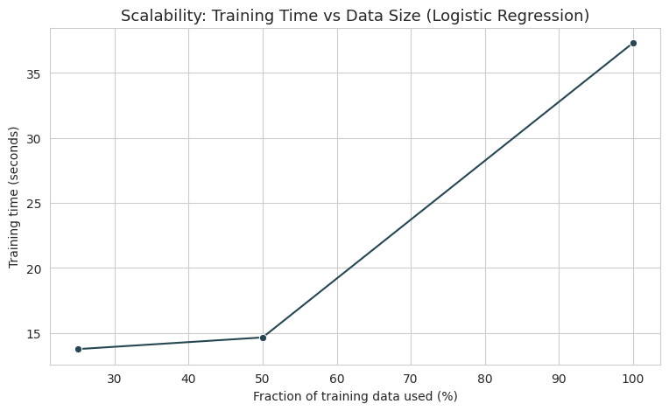
Figure 7: Scalability

5.9 Validation Against Research Question
The results indicate that PySpark-enabled machine learning can handle large amounts of transaction data while it allows comparing fraud detection. The GBT produced the best ROC AUC (0.9127), while the Logistic regression needed the least amount of time for training (37.31 seconds). Thus, the results offer an indication of a measurable trade-off between predictive ability and computational efficiency. The overall assessment shows that the project achieved the technical goals.

Project Planning Review
Reflection on Project Planning
This project has gone through the same sequence of phases involving literature search, preparation of the dataset, and implementation of PySpark, followed by developing, testing, evaluating and writing the report. Generally, the envisaged plan was similar to the one implemented; however, it took longer than planned to prepare the data, make the data set balanced, train the model, and perform evaluation. The implementation had to go through multiple rounds of testing to make sure that the three models were comparable and provided good results. The project had the main deviation from the original plan noticed by the limited external user testing. Initially, user acceptance was taken into account, but only internal testing was done. Thus, the project mainly relied on its own performance statistics and functional tests. Another deviation was modeling with respect to balancing performance with computational efficiency, which became very important after noticing the long training time of Random Forest, GBT, and Logistic Regression.
The Gantt Chart represented as below-
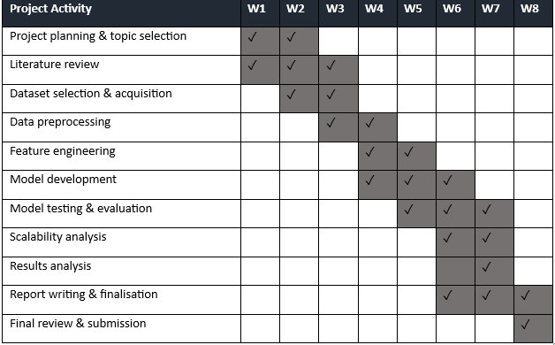

Conclusion

7.1 Achievement of Objectives
The project was a success and explored the use of scalable machine learning models for financial fraud detection using big data technologies. The research was designed to create a PySpark based fraud detection framework which included the functionalities of data preprocessing, feature engineering, model development, performance evaluation and scalability analysis. The project required to fill the research gap by comparing Logistic Regression, Random Forest and Gradient Boosted Trees under distributed machine learning.

7.2 Answering the Research Question
The experimental results showed that there were significant differences among the three models. Logistic Regression took the least number of seconds in training (37.31 seconds) but the lowest ROC-AUC (0.8191). In the case of Random Forest, the predictive performance is better with 0.8959 ROC-AUC and the training time is about 187.83 seconds. Gradient Boosted Trees had the best overall discrimination, at 0.9127 ROC-AUC and 80.13% fraud recall, but the training time was the longest using about 264.27 seconds. These findings highlight the balance between model performance and efficiency and contribute to the project's goal of examining scalable fraud detection strategies.

7.3 Contribution of the Deliverable
The development may make the framework more useful for banks, FinTech organisations, cybersecurity analysts and online payment platforms to prevent financial fraud more quickly and effectively.

7.4 Lessons Learned
The findings derived from the analyses could help in exploring automated model retraining to adapt to evolving fraud patterns, explainable AI to enable financial analysts to grasp fraud predictions, and integration with real-time transaction monitoring systems.

7.5 Limitations
The project encountered limitations in terms of its methodology approach in that it only utilized one dataset and restriction in computational capacity. External stakeholders were not employed in the stage of testing, which limited the amount of evidence on practicality.

7.6 Recommendations
Other machine learning and deep learning models might be also compared. Methods such as real-time streaming, automated model retraining, explainable AI, and testing with external stakeholders should be also planned to be used in order to increase practicality of the studied question.

7.7 Future Research
The identified future project objective of improving the framework for real-time fraud detection environments could be explored. Larger and more diverse financial datasets could be explored, as could other machine learning and deep learning algorithms, as well as novel approaches to hyperparameter optimization and handling extreme class imbalance.

AI Transparency Statement

8.1 AITS Classification
The study utilized AI-assisted tools only in regard to language refinement, organisation and proofreading, while AI was not used in research performance, generation of experiments results and taking decisions about the accomplishment of the study.

8.2 AI Tools Used
Generative AI tools were relevant in any area of project documentation preparation, including proofreading process, improvement of wording, section structure and identification of unclear parts.

8.3 Purpose of AI Use
AI helped to enhance the report by improving its clarity, grammar and structure. It was also helpful in terms of assessing the way how technical information was presented in the report.

8.4 Human Contribution
All the key components of the project, such as planning of the study, selection of literature, preparation of datasets, implementation of PySpark, development of the model, its testing, evaluation and results interpretation were carried out by the researcher.

8.5 Reflection on AI Use
Assistance from AI was beneficial for improving both the clarity and structure of the project documentation and the identification of grammatical or presentation errors. However, the outputs received from AI were treated as suggestions rather than authoritative information. The researcher reviewed and verified everything generated by AI before it was used in the project.

References
‌Alketbi, A. (2025). Real-Time Fraud Detection using Big Data Real-Time Fraud Detection usingBigData. https://repository.rit.edu/cgi/viewcontent.cgi?article=13380&context=theses
‌Bello, A., & Olufemi, K. (2024). Artificial intelligence in fraud prevention: Exploring techniques and applications challenges and opportunities. Computer Science & IT Research Journal, 5(6), 1505–1520. https://doi.org/10.51594/csitrj.v5i6.1252
‌Cheng, C. (2025). Research on Fraudulent Transaction Detection. Applied and Computational Engineering, 158(1), 35–40. https://doi.org/10.54254/2755-2721/2025.tj23322
‌Gupta, R., Jindal, R., Naik, A., & Tripathi, A. (2025). Applying Logistic Regression for the Detection of Fraudulent Banking Transactions. ResearchGate, 47(02). https://www.researchgate.net/publication/392331388_Applying_Logistic_Regression_for_the_Detection_of_Fraudulent_Banking_Transactions
‌Hareram, S. E. (2025). Technical Review: Apache Spark and PySpark for Distributed Data Processing. Zenodo. https://doi.org/10.5281/zenodo.16491755
Liu, C., Tang, H., Yang, Z., Ke, Z., & Cha, S. (2025). Big Data-Driven Fraud Detection Using Machine Learning and Real-Time Stream Processing. arXiv.Org. https://arxiv.org/abs/2506.02008
‌Naghipour, S. A., far, & Nazari, R. (2025). Fraud Analytics with Big Data: A Literature Review on Machine Learning Algorithms in Bankruptcy Prediction and Financial Fraud Detection. National Conference on Information Technology, Nanotechnology, Artificial Intelligence and Technological Futures Studies. https://www.researchgate.net/publication/397446053_fraud_analytics_with_big_data_a_literature_review_on_machine_learning_algorithms_in_bankruptcy_prediction_and_financial_fraud_detection
‌Owen, A., Emma, O., & Adams, R. (2024). Evaluating the Role of Class Imbalance in Fraud Detection Algorithms. In ResearchGate. unknown. https://www.researchgate.net/publication/388817710_Evaluating_the_Role_of_Class_Imbalance_in_Fraud_Detection_Algorithms
Theodorakopoulos, L., Theodoropoulou, A., Tsimakis, A., & Halkiopoulos, C. (2025). Big Data-Driven Distributed Machine Learning for Scalable Credit Card Fraud Detection Using PySpark, XGBoost, and CatBoost. Electronics, 14(9), 1754. https://doi.org/10.3390/electronics14091754
Wiltshire, D., & Alvanides, S. (2022). Ensuring the ethical use of Big Data: lessons from secure data access. Heliyon, 8(2). https://doi.org/10.1016/j.heliyon.2022.e08981

Appendix

Appendix A - AI declaration
I declare that Artificial Intelligence (AI) tools were used during the preparation of this dissertation as a supporting resource. AI was used for limited purposes such as improving the clarity and structure of written material, assisting with language and grammar checking, generating ideas for organising sections, and supporting the refinement of academic wording.
The research topic, research objectives, methodology, analysis, interpretation of findings and conclusions were developed and critically evaluated by me. I reviewed, verified and edited any AI-assisted content before incorporating it into the dissertation. Where information or academic claims were used, appropriate academic sources were independently identified and referenced in accordance with the required referencing guidelines.
AI tools were not used as a replacement for independent critical thinking, academic judgement or the evaluation of research evidence. Responsibility for the accuracy, originality, academic integrity and final content of this dissertation remains entirely with me.
I have also ensured that the use of AI complies with the relevant university policies and academic integrity requirements governing the use of generative AI in assessed work.

Appendix B - Ethics Form
UREC2 RESEARCH ETHICS PROFORMA FOR STUDENTS UNDERTAKING LOW RISK PROJECTS WITH HUMAN PARTICIPANTS

This form is designed to help students and their supervisors to complete an ethical scrutiny of proposed research. The University Research Ethics Policy (www.shu.ac.uk/research/excellence/ethics-and-integrity/policies) should be consulted before completing this form. The initial questions are there to check that completion of the UREC 2 is appropriate for this study. The final responsibility for ensuring that ethical research practices are followed rests with the supervisor for student research.

Note that students and staff are responsible for making suitable arrangements to ensure compliance with the General Data Protection Act (GDPR). This involves informing participants about the legal basis for the research, including a link to the University research data privacy statement and providing details of who to complain to if participants have issues about how their data was handled or how they were treated (full details in module handbooks). In addition, the act requires data to be kept securely and the identity of participants to be anonymised. They are also responsible for following SHU guidelines about data encryption and research data management. Guidance can be found on the SHU Ethics Website www.shu.ac.uk/research/excellence/ethics-and-integrity

Please note that it is mandatory for all students to only store data on their allotted networked F drive space and not on individual hard drives or memory sticks etc.

The present form also enables the University and College to keep a record confirming that research conducted has been subjected to ethical scrutiny.

The form must be completed by the student and the supervisor and independently reviewed by a second reviewer or module leader (additional guidance can be obtained from your College Research Ethics Chair). In all cases, it should be counter-signed and kept as a record showing that ethical scrutiny has occurred. Some courses may require additional scrutiny. Students should retain a copy for inclusion in their research projects, and a copy should be uploaded to the relevant module Blackboard site.

Please note that it may be necessary to conduct a health and safety risk assessment for the proposed research. Further information can be obtained from the University’s Health and Safety Website https://sheffieldhallam.sharepoint.com/sites/3069/SitePages/Risk-Assessment.aspx

SECTION A

- Checklist questions to ensure that this is the correct form:

Health Related Research within the NHS, or His Majesty’s Prison and Probation Service (HMPPS), or with participants unable to provide informed consent check list.

Question | Yes/No
Does the research involve?
- Patients recruited because of their past or present use of the NHS | No
- Relatives/carers of patients recruited because of their past or present use of the NHS | No
- Access to NHS staff, premises, or resources | No
- Access to data, organs, or other bodily material of past or present NHS patients | No
- Foetal material and IVF involving NHS patients | No
- The recently dead in NHS premises | No
- Prisoners or others within the criminal justice system recruited for health-related research | No
- Police, court officials, prisoners, or others within the criminal justice system | No
- Participants who are unable to provide informed consent due to their incapacity even if the project is not health related | No
- Is this an NHS research project, service evaluation or audit?  For NHS definitions please see the following website http://www.hra.nhs.uk/documents/2013/09/defining-research.pdf | No

If you have answered YES to any of the above questions, then you MUST consult with your supervisor to obtain research ethics from the appropriate institution outside the university. This could be from the NHS or Her Majesty’s Prison and Probation Service (HMPPS) under their independent Research Governance schemes. Further information is provided below. https://www.myresearchproject.org.uk/

- Checks for Research with Human Participants

Question | Yes/No
- Will any of the participants be vulnerable?  Note: Vulnerable people include children and young people, people with learning disabilities, people who may be limited by age or sickness, pregnancy, people researched because of a condition they have, etc. See full definition on ethics website in the document Code of Practice for Researchers Working with Vulnerable Populations (under the Supplementary University Polices and Good Research Practice Guidance) | No
- Are drugs, placebos, or other substances (e.g., food substances, vitamins) to be administered to the study participants or will the study involve invasive, intrusive, or potentially harmful procedures of any kind? | No
- Will tissue samples (including blood) be obtained from participants? | No
- Is pain or more than mild discomfort likely to result from the study? | No
- Will the study involve prolonged or repetitive testing? | No
- Is there any reasonable and foreseeable risk of physical or emotional harm to any of the participants?  Note: Harm may be caused by distressing or intrusive interview questions, uncomfortable procedures involving the participant, invasion of privacy, topics relating to highly personal information, topics relating to illegal activity, or topics that are anxiety provoking, etc. | No
- Will anyone be taking part without giving their informed consent? | No
- Is the research covert?  Note: ‘Covert research’ refers to research that is conducted without the knowledge of participants. | No
- Will the research output allow identification of any individual who has not given their express consent to be identified? | No

If you have answered YES to any of these questions you are REQUIRED to complete and submit a UREC3 or UREC4 form. Your supervisor will advise. If you have answered NO to all these questions, then proceed with this form (UREC2).

- General Project Details

Details
Name of student | Tarun Singuluri
SHU email address | C4064048@hallam.shu.ac.uk
Department/College | MSc in Big Data Analytics
Name of supervisor | Olamilekan Shobayo
Supervisor’s email address | O.SHOBAYO@shu.ac.uk
Title of proposed research | Research on Scalable Machine Learning for Fraud Detection Using Big Data Technologies
Proposed start date | 12 June 2026
Proposed end date | 10 September 2026
Background to the study and the rationale (reasons) for undertaking the research (500 words) | Online transactions and digital financial services have made financial fraud one of the biggest problems for banks, ecommerce companies, insurance companies and digital payment providers. Fraud detection methods, such as rule-based systems and manual auditing are not suited to detecting more complex and widespread fraud. The massive amount of transaction data generated and transmitted continuously, with high volumes, velocity and variety has prompted the need for scalable machine learning solutions that are able to process and analyse big data with efficiency (Liu et al., 2025). Large data technologies like distributed computing platforms, Hadoop, and Apache Spark, can help machine learning models process millions of transactions in real time without compromising on the accuracy of the detection. Machine learning methods such as Random Forest, XGBoost, Gradient Boosting and Deep Neural Networks have proven to be more efficient than traditional statistical methods at detecting intricate fraud patterns. But there are difficulties in scaling, optimizing for computation, model precision and finding rare fraudulent events in extremely imbalanced datasets.
Aims & research question(s) | This study aims to develop and evaluate a scalable and efficient fraud detection framework using PySpark-based machine learning models for analysing large-scale financial transaction data in real-time environments.  - What are the potential benefits of the use of scalable machine learning models that integrate big data technologies for the more accurate, efficient and scalable detection of fraud in large scale financial transaction databases?  - Which machine learning algorithm provides the best performance for detecting fraudulent financial transactions when implemented using big data technologies?  - What impact do big data frameworks have on the computational performance, scalability, and processing time of machine learning-based fraud detection systems?
Methods to be used for:  - Recruitment of participants  - Data collection  - Data analysis | Secondary Data will be used  Dataset Link - https://www.kaggle.com/datasets/lnasiri007/ieeecis-fraud-detection  Practical Approach/Data Analysis - The practical work will start with Data Pre-processing techniques applied with PySpark (data cleaning, feature engineering, class imbalanced techniques, and encoding of categorical variables as numbers). Exploratory Data Analysis (EDA) will then be performed to gain insight into the distribution of transactions, fraud and their relationships with the features. Then scalable machine learning models such as Logistic Regression, Random Forest, and Gradient Boosted Trees will be created with Spark MLlib and applied to the distributed data set. Model performance will be measured using the following metrics: Accuracy, Precision, Recall, F1-Score, ROC-AUC, and Confusion Matrix. Computational performance will be measured by execution time, scalability, and resource utilization in PySpark. Lastly, the models developed will be compared to determine the most effective and scalable model to detect fraudulent financial transactions in a big data environment.
Outline the nature of the data held, details of anonymisation, storage and disposal procedures as required. | The proposed research will be based on the publicly available dataset from IEEE-CIS Fraud Detection dataset from Kaggle which provides a real-world ecommerce transaction and identity data set from Vesta Corporation for fraud detection research purposes. This data is anonymous and has been anonymised prior to release to protect the privacy of users. Personal customer information like their identities, their payment, and personally identifiable information (PII) has been deleted or anonymised to a feature group (e.g., V1-V339, C1-C14, D1-D15), while still having an analytical value, but not allowing to identify single users.  A password protected personal computer with encrypted storage will be used to store the dataset, which will be backed up regularly to a secure institutional cloud repository. Access will only be granted to the researcher for academic research. No effort will be made to re-identify individuals, or to merge the data set with external personal data. All local copies and processed datasets, intermediate files, and other files required for the project will be securely deleted after completion of the project, and only non-identifiable research outputs and documentation will be kept for academic recordkeeping purposes in accordance with institutional data management guidelines and policies.

4. Research in External Organizations

Question | Yes/No
- Will the research involve working with/within an external organization (e.g., school, business, charity, museum, government department, international agency, etc.)? | No
- If you answered YES to question 1, do you have granted access to conduct the research from the external organization?  If YES, students please show evidence to your supervisor. You should retain this evidence safely. | No
- If you do not have permission for access is this because:  - you have not yet asked  - you have asked and not yet received an answer  - you have asked and been refused access  Note: You will only be able to start the research when you have been granted access. | No

- Research with Products and Artefacts

Question | Yes/No
1. Will the research involve working with copyrighted documents, films, broadcasts, photographs, artworks, designs, products, programs, databases, networks, processes, existing datasets, or secure data? | No
2. If you answered YES to question 1, are the materials you intend to use in the public domain?  Notes: ‘In the public domain’ does not mean the same thing as ‘publicly accessible’.  - Information which is 'in the public domain' is no longer protected by copyright (i.e., copyright has either expired or been waived) and can be used without permission.  - Information which is 'publicly accessible' (e.g., TV broadcasts, websites, artworks, newspapers) is available for anyone to consult/view. It is still protected by copyright even if there is no copyright notice. In UK law, copyright protection is automatic and does not require a copyright statement, although it is always good practice to provide one. It is necessary to check the terms and conditions of use to find out exactly how the material may be reused etc.  If you answered YES to question 1, be aware that you may need to consider other ethics codes. For example, when conducting Internet research, consult the code of the Association of Internet Researchers; for educational research, consult the Code of Ethics of the British Educational Research Association. | No
3. If you answered NO to question 2, do you have explicit permission to use these materials as data?  If YES, please show evidence to your supervisor. | No
4. If you answered NO to question 3, is it because:  A. you have not yet asked permission  B. you have asked and not yet received and answer  C. you have asked and been refused access.  Note: You will only be able to start the research when you have been granted permission to use the specified material. | A/B/C

SECTION B

HEALTH AND SAFETY RISK ASSESSMENT FOR THE RESEARCHER
- Does this research project require a health and safety risk assessment for the procedures to be used? (Discuss this with your supervisor)

Yes
No

If YES the completed Health and Safety Risk Assessment form should be attached. A standard risk assessment form can be generated through the Awaken system (https://shu.awaken-be.com). Alternatively if you require more specific risk assessment, e.g. a COSHH, attach that instead.

- Will the data be collected fully online (no face-to-face contact with participants)?

Yes (See the safety guidance for online research and go to question 7b)
No (Go to question 3)

- Will the proposed data collection take place on campus?

Yes (Please answer questions 5 to 8)
No (Please complete all questions and consult with your supervisor))

- Where will the data collection take place?
(Tick as many as apply if data collection will take place in multiple venues)

 | Location | Please specify
 | Researcher's Residence
 | Participant's Residence
 | Education Establishment
 | Other e.g., business/voluntary organisation, public venue
 | Outside UK

- How will you travel to and from the data collection venue?

On foot By car Public Transport
Other (Please specify)
Please outline how you will ensure your personal safety when travelling to and from the data collection venue.
N/A

- How will you ensure your own personal safety whilst at the research venue?

N/A

- Are there any potential risks to your health and wellbeing associated with either (a) the venue where the research will take place and/or (b) the research topic itself?

None that I am aware of
Yes (Please outline below including steps taken to minimise risk)

- If you are carrying out research off-campus, you must ensure that each time you go out to collect data you ensure that someone you trust knows where you are going (without breaching the confidentiality of your participants), how you are getting there (preferably including your travel route), when you expect to get back, and what to do should you not return at the specified time.

Please outline here the procedure you propose using to do this.

N/A

Insurance Check

The University’s standard insurance cover will not automatically cover research involving any of the following:

i) Participants under 5 years old
ii) Pregnant women
iii) 5000 or more participants
iv) Research being conducted in an overseas country
v) Research involving aircraft and offshore oil rigs
vi) Nuclear research
vii) Any trials/medical research into Covid 19

If your proposals do involve any of the above, please contact the Insurance Manager directly (fin-insurancequeries-mb@exchange.shu.ac.uk) to discuss this element of your project.

Adherence to SHU Policy and Procedures

Ethics sign-off
Personal statement
I can confirm that:
- I have read the Sheffield Hallam University Research Ethics Policy and Procedures
- I agree to abide by its principles.
Student
Name: Tarun Singuluri | Date: 26-07-2026
Signature: Tarun
Supervisor ethical sign-off
I can confirm that completion of this form has not identified the need for ethical approval by the TPREC/CREC or an NHS, Social Care, or other external REC. The research will not commence until any approvals required under Sections 4 & 5 have been received and any necessary health and safety measures are in place.
Name: Olamilekan Shobayo | Date: 30-07-2026
Signature:
Independent Reviewer ethical sign off

Name: | Date:
Signature:

Please ensure that you have attached all relevant documents. Your supervisor must approve them before you start data collection:

Documents | Yes | No | N/A
Research proposal if prepared previously
Any recruitment materials (e.g., posters, letters, emails, etc.)
Participant information sheet
Participant consent form
Details of measures to be used (e.g., questionnaires, etc.)
Outline interview schedule / focus group schedule
Debriefing materials
Health and Safety Risk Assessment Form

‌

Appendix C: Executed Publication Procedure Form


Research Skills and Dissertation Module
(55-706556)
PUBLICATION PROCEDURE FORM
In this module, while you create your own research question or topic area, your supervisor makes a significant intellectual contribution to this work as the research progresses. Your supervisor will make the decision on whether your work merits publication based on the quality of the work you have produced. Your supervisor will co-author the paper for publication with you and your supervisor will both be listed as an author. You are required to sign the declaration below to confirm that you understand and will follow this procedure.
Declaration:
Declaration | Signature | Date
I Tarun Singuluri confirm that I understand will comply with the Publication Procedure outlined in the Module Handbook and the Blackboard Site.
Student: Tarun Singuluri | Tarun | 09/09/2026
Supervisor: Olamilekan Shobayo |  | 10/09/2026
Publication Procedure Form declaration, to be signed by the student and the supervisor before the project begins.
Note: this form is to be completed in discussion with the supervisor before the project begins and included in the final submission, as required by the Module Handbook.

Appendix D: Secondary Data
Dataset Link - https://www.kaggle.com/datasets/lnasiri007/ieeecis-fraud-detection

Appendix E: Original Research Project Plan
Task | Baseline Description | Methodology Milestone
Literature Review | Review fraud detection and scalable ML literature | Literature foundation
Dataset Preparation | Acquire, clean and preprocess IEEE-CIS data | Data preparation
Model Development | Implement three PySpark ML models | Model development
Testing & Evaluation | Assess accuracy, scalability and efficiency | Evaluation
Final Report | Analyse findings and document outcomes | Project completion

Appendix F: Gantt Chart — Planned vs. Actual Execution
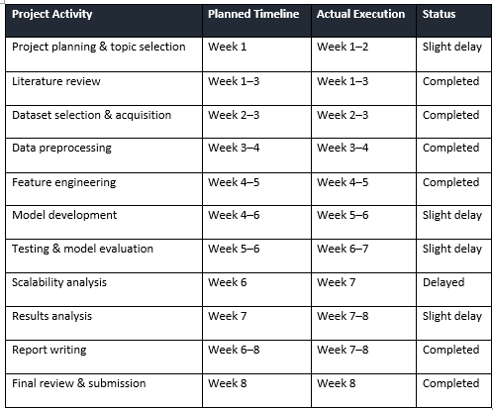

Appendix G: Literature Review Evidence
Search Strings
Search String
"financial fraud" AND "machine learning" AND detection
"fraud detection" AND "Logistic Regression" AND "Random Forest"
"fraud detection" AND "Gradient Boosted Trees"
"financial fraud" AND PySpark AND scalability
"Apache Spark" AND "fraud detection" AND "machine learning"
"class imbalance" AND "financial fraud detection"

Database Searches
Database | Reason
IEEE Xplore | Computing, AI and machine learning
ACM Digital Library | Computer science and data analytics
ScienceDirect | Machine learning and financial technology
SpringerLink | Big data and computational research
Google Scholar | Broader academic literature and citation tracking

Screening process
The search results were filtered through several phases. First, titles and abstracts were checked against the research theme. All potentially relevant papers were analysed in their entirety. The duplicates, irrelevant or inadequate papers were omitted. The selected literature was reviewed based on themes like machine learning algorithms, scalability issues, class imbalance and computing performance issues.
Inclusion and exclusion
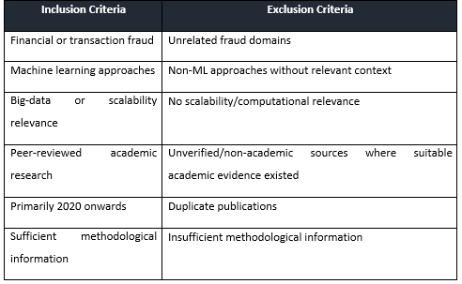
Paper Selection Summary
The literature chosen for the study included machine learning fraud detection, PySpark/Apache Spark, class imbalance, evaluation metrics and scalability. The evidence indicated the importance of comparing Logistic Regression, Random Forest, and Gradient Boosted Trees and revealed that there was a gap in research on the evaluation of prediction efficiency and computing scalability for fraud detection.

Appendix H: Risk Artefacts
Risk Log: Possible risk factors may include class imbalances, lack of data, computing constraints, data errors, and underperforming models.
Risk Register
Risk | Likelihood | Impact | Mitigation
Class imbalance | High | High | Class weighting and using several metrics
Computational constraints | Medium | High | PySpark use and optimizing processing
Missing/poor-quality data | Medium | Medium | Data pre-processing and validation
Model underperformance | Medium | High | Three algorithms comparison

Risk Matrix
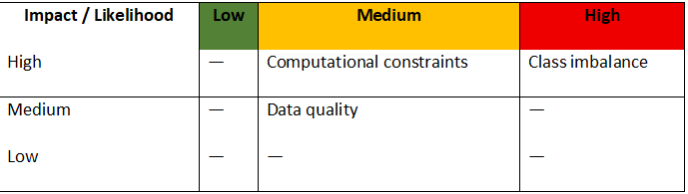

College of Social Sciences and Arts - Dr. Antonia Ypsilanti (a.ypsilanti@shu.ac.uk ) College of Business, Technology and Engineering - Dr. Tony Lynn (t.lynn@shu.ac.uk ) College of Health, Wellbeing and Life Sciences - Dr. Nikki Jordan-Mahy (n.jordan-mahy@shu.ac.uk )
Safety guidance for online research includes information on how to set up online surveys and/or conduct online interviews/focus groups. These guidelines can be found in BB. Please check with your supervisor/module leader.
It is mandatory to attach the Participant Information Sheet (PIS)
It is mandatory to attach a Participant Consent Form, unless it is embedded in an online survey, in which case your supervisor must approve it before you start data collection

